MBEDZI MASINDI
ST10491611

WEB DEVELOPMENT
WEDE5020

Table of Contents
Luxury Glow Hair & Beauty Salon 2
Organisation Overview 2
Website Goals and Objectives 2
Current Website Analysis 3
Proposed Website Features and Functionality 3
Design and User Experience 4
Technical Requirements 4
Timeline and Milestones 4
Budget 5
REFERENCES 6

Luxury Glow Hair & Beauty Salon
Proposal for Luxury Glow Hair & Beauty Salon
Prepared by: Masindi Mbedzi
Date: 05 August 2026

Luxury Glow Hair & Beauty Salon

Organisation Overview
- Brief Description: Luxury Glow Hair & Beauty Salon was founded in 2019 as a boutique salon offering personalized beauty services, the salon is in Limpopo (Polokwane). The salon quickly gained popularity through word-of-mouth and social media attracting a loyal client base.
- Mission & Vision: The mission is to empower clients through self-care, enhancing confidence with professional treatments. The vision is to become the go-to salon for modern, affordable luxury in the local community.
- Target Audience: Women aged 18-50 seeking high-quality beauty services in a relaxed and welcoming environment, offering young professionals and students who knows about style.

Website Goals and Objectives
The goal of the website is to serve as a digital hub for the salon, allowing clients to easily access information and book appointments. The objectives of the website include:
- Increase online bookings
- Showcase services and portfolios
- Build brand awareness and credibility
KPIs: Success will be measured by monthly appointment bookings, website traffic and engagement and customer feedback forms.

Current Website Analysis
Currently, Luxury Glow Hair and Beauty Salon don’t have a website but is working on opening an Instagram page and Facebook page for promotion.
Strength: High-quality beauty services with trained professionals.
Weakness: No official website for customers to access information.
Area of Improvement: Develop a professional, mobile-friendly website to strengthen the salon’s online presence.

Proposed Website Features and Functionality
- Homepage: with hero image and booking buttons
- About Us page: with salon story, team profiles and values.
- Services pages: (Hair, Nails and Lashes)
- Book Appointment system: Scheduling tool with a calendar view.
- Gallery: Showcasing client transformations.
- Contact page: Including map, phone, email and links.
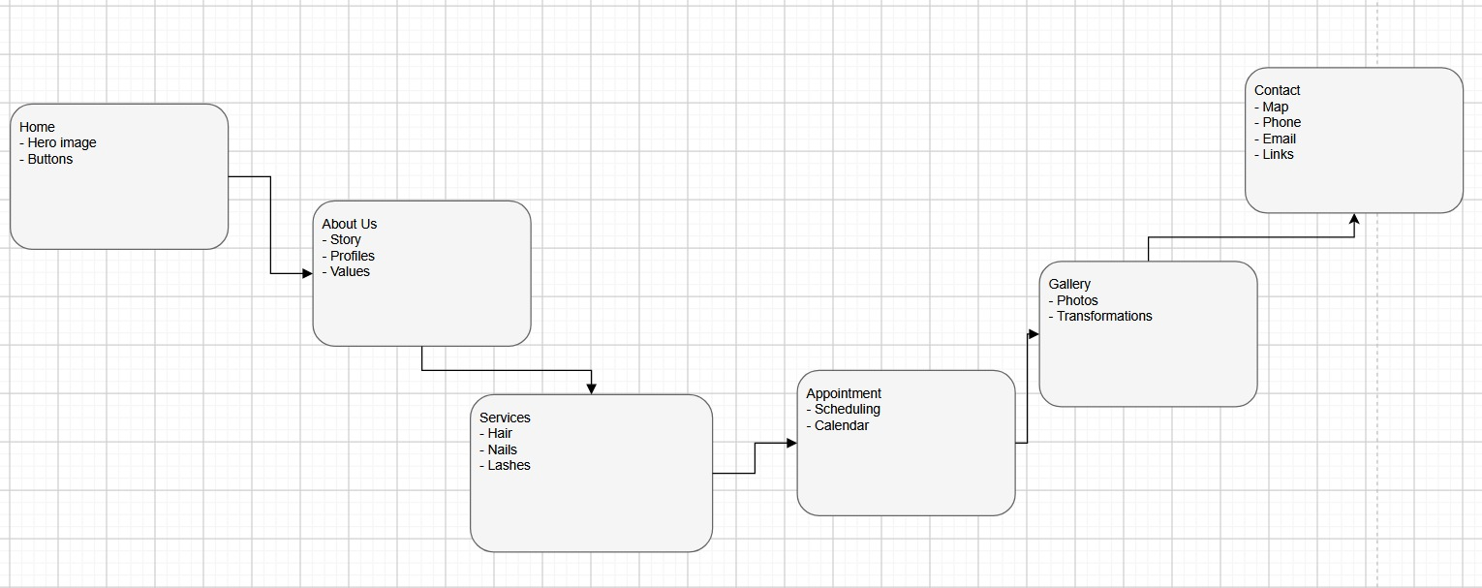

Design and User Experience
Color scheme: The design will use a soft pink and white color scheme to reflect elegance and femininity.
Typography: will combine elegant serif fonts for headings and clean sans-serif for body text.
Headings: Poppins Bold
Subheadings: Poppins Semi-Bold
Body Text: Open Sans Regular
The layout will be minimalist and image-driven, with clear call to action buttons.

User Experience Consideration
The website will prioritize ease of use and customer convenience by providing:
A simple and consistent navigation menu on every page

Technical Requirements
The website will be hosted on a secure shared hosting platform with SSL certification. The domain name will be luxuryglow.co.za. The development will use HTML, CSS and JavaScript with Wordpress CMS for flexibility and ease of updates.

Timeline and Milestones
- Week 1: Planning, content creation and wireframes.
- Week 2-3: Development and Integration of booking system.
- Week 4: Testing, feedback and Launch

Budget
Development: R15,000
Hosting & Domain: R2,000/year
Maintenance: R6,000/year

REFERENCES
Hubspot (2023) Best practice for service based business websites. Available at: https://blog.hubspot.com (Accessed: 5 August 2026).
Small Business Administration (2024) Creating an online presence for small businesses. Available at: https://www.sba.gov (Accessed: 5 August 2026).
Statista (2024) Beauty salon industry in South Africa- market size and trends. Available at: https://www.statista.com (Accessed: 5 August 2026).

